English title

DOI: 10.58042/

Submitted: Feb 05, 2026
Approved: Mar 15, 2026

Author Name
Highest academic qualification in the area
Affiliation:
Address: City, Province/State, Country
E-mail: xxxxxxxxxx1@outlook.com

Author Name
Highest academic qualification in the area
Affiliation:
Address: City, Province/State, Country
E-mail: xxxxxxxxxx1@outlook.com

ABSTRACT
The abstract of the upcoming paper aims to provide a comprehensive overview of the research, following the guidelines of relational coherence. Starting with the justification of the study, which highlights the need to address a specific problem or gap in the existing literature, the research objectives are outlined. A specific methodology is then employed to achieve these objectives. Through this methodology, the study seeks to investigate and analyze various aspects related to the identified problem. The research findings are discussed, emphasizing key discoveries and insights, contributing to a deeper understanding of the issue at hand. Finally, based on the findings, conclusions are drawn, shedding light on the implications and significance of the study's findings. For concept-based papers, the sections can be much different and may not include a methodology section; however, it should situate the research within the field and explain its significance. The abstract encapsulates the essence of the forthcoming publication, aligning with established academic conventions. This abstract, containing 150 to 250 words, is crucial for conveying succinctly and clearly the main points of the research (Souza, 2022).

Keywords: Between 4 and 6 keywords, separated by commas, in alphabetical order. For example: decolonization, epistemic injustice, rhizome, teacher education.

NOTE: Please submit this title page as a separate document. Full manuscript for anonymized peer review file should begin on second page (i.e., please submit 2 separate files).

Introduction
Provide a description of the contextualization, research topic, and justification of the research using Times New Roman font size 12, with a line spacing of 1.5. Regarding the length of the manuscript, it should consist of a maximum of 8000 words, including references. The manuscripts should be written in English. At the end of the introduction, the goal/purpose of the paper should be clearly outlined.
Theoretical Framework
The theoretical framework in a study comprises a critical and organized analysis of the literature relevant to the topic, providing a theoretical contextualization and defining the key concepts. It must comprehensively contain theories, models and previous research, identifying gaps, contradictions and consensuses in the literature that are important for the focus of the work being developed. The theoretical framework section could be replaced with a literature review and/or conceptual framework section, depending on the goals of the paper. Please note that you may also change the language of the headings and sub-headings; however, the formatting (i.e., spacing, font, etc.) should remain the same as this template.

Tables
Authors must use the American Psychological Association 7th edition (APA 7) standards for citations and references. In the case of images, every form of presentation used in the work must be named Table or Figure. Everything that is not a table will be considered a figure. Examples: drawing, scheme, flowchart, photograph, graph, map, organization chart, plan, picture, portrait, image, among others. The table or figure should be referenced in-text.
The title of the table should be brief, clear, and explanatory. It should be placed above the table, in the upper left corner, just below the word Table (with the initial capital letter) and accompanied by the number that designates it (tables should be numbered with Arabic numbers sequentially within the text as a whole). Example: Table 1, Table 2, Table 3, etc.
The table title font should be the same as the one used in the text, in bold type and with a spacing of 1.5 cm between the table number and the title of its identification that will appear below aligned to the left and in italics. The citation font should be bold and single-spaced, below the left-aligned table, Times New Roman 10 font. Indicate the source when the table is extracted from another work (do not indicate if it is the author's own). Please reference the consulted document.
For example:

Table 1
Example table
Sample table showing decked heads and P-value note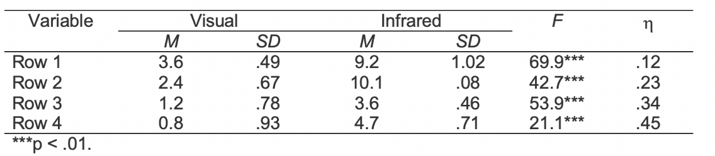
Source: Purdue Online Writing Lab (n.d., Tables and Figures)

Figures
The title explains the figure concisely but discursively. The font in the title of the figure should be the same as that used in the text, in bold type and with a spacing of 1.5 cm between the figure number and the title of its identification, which will appear below in left-aligned italics. Numbered with Arabic numerals sequentially within the text as a whole, preceded by the word figure (with the initial capitalization). Example: Figure 1, Figure 2, Figure 3, etc. The citation font should be single-spaced, below the left-aligned figure, Times New Roman 10 font. Indicate the source when the figure is extracted from another work (do not indicate if it is the author's own). Please reference the consulted document. An image description should be included before the source.
For example:

Figure 1
Pedagogical narration as processual practice
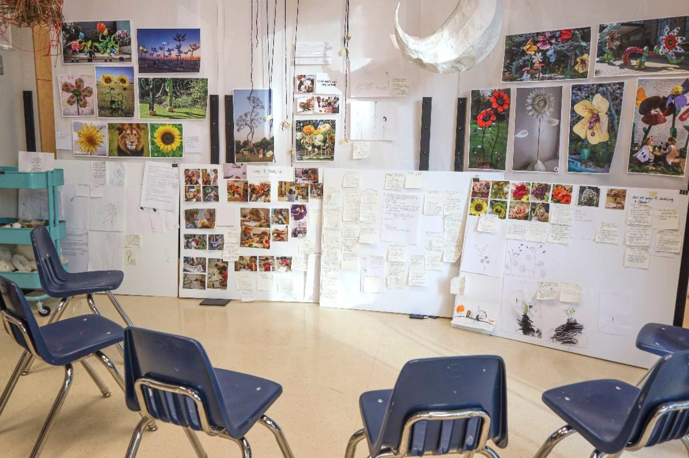
Image Description: Five blue, plastic chairs surround pedagogical documentation boards, which include photographs, drawings, and handwritten notes related to children’s ways of thinking with flowers. On the wall above the documentation boards, there are images of artists’ sculptural works. The room is bright and feels open for artistic engagement and dialogue.
Source: Kind (2023, p. 2).

Methodology
The methodology of an article outlines the procedures employed to conduct the research, including the type of study, sample selection, data collection and analysis methods, ethical considerations, and limitations of the study. Its detailed and transparent description is essential to provide a solid basis for the interpretation of the findings. The methodology section is not mandatory if the manuscript is a conceptual paper submission.

Findings and Discussions
The findings and discussions of an article must be presented in a clear and organized manner, based on the data collected and the analysis carried out during the study. Limitations of the study and possible directions for future research are discussed. It is essential that both the findings and the discussion are based on the data presented in the paper and that they contribute significantly to the advancement of knowledge on the topic addressed.

Conclusion
The conclusion of an article should summarize the main findings of the study succinctly, highlighting the significant contributions to the research field. It should reiterate the objectives of the study and summarize the most important findings and/or arguments, emphasizing their relevance and practical or theoretical implications.

Acknowledgements
This is an optional section, where the author can thank the funding agencies or other applicable recognitions.

References
References should be in American Psychological Association 7th edition (APA 7) standards, placed in alphabetical order. Justified alignment, in the second line of the reference onwards, an indentation of 0.75 is made. Single line spacing. Some people do not differentiate between first/given and last/family names. Please consult previous publications of the author to ensure citing their names properly.

Book:
Author’s Last/Family Name(s), First/Given Name(s) Initials. (Year of publication). Book title in italics. Publisher.
Book Example:
Sensoy, Ö., & DiAngelo, R. (2017). Is everyone really equal?: An introduction to key concepts in social justice education (2nd ed.). Teachers College Press.

Book Chapter:
Last/Family Name(s) of the Author of the Chapter, First/Given Name(s). (Year of publication). Title of the chapter. In Initials and Last/Family Name(s) of the Book Editor (Ed.), Title of the book in italics (pp. chapter pages). Publisher.
Book Chapter Example:
Keenan, H. B., Mess, L. M. H., Newbold, L., & Iskander, L. (2023). Out of the classroom and onto the runway: Queer and trans pedagogies in early childhood. In H. Yoon, A. L. Goodwin, & C. Genishi (Eds.), Reimagining diversity, equity, and justice in early childhood (pp. 181-191). Routledge.

Journal Article:
Author’s Last/Family Name(s), First/Given Name(s) Initials. (Year of publication). Title of the article. Title of the Journal in Italics, volume(number), start page–end page. DOI website or source site if no DOI.

Journal Article Example:
Kind, S. (2023). Being in-the-making of pedagogical narrations: An atelierista’s perspective. Journal of Childhoods and Pedagogies, 2(2), 1-5. https://journalofchildhoodsandpedagogies.ca/index.php/jcp/article/view/183

Thesis or Dissertation:
Author’s Last/Family Name(s), First/Given Name(s) Initials. (Year). Title of dissertation or thesis (Publication No.) [Doctoral dissertation or master’s thesis, Name of Institution Awarding Degree]. Database Name. website if applicable.
Thesis or Dissertation Example:
Itani, S. (2015). Japanese female and ‘trans’ athletes: Negotiating subjectivity and media constructions of gender, sexuality, and nation [Doctoral dissertation, University of Toronto]. TSpace University of Toronto Database. http://hdl.handle.net/1807/69751

Website:
Author’s Last/Family Name(s), First/Given Name(s) Initials. (Year, Month Date). Title of page. Site Name. URL
Website Example:
Purdue Online Writing Lab. (n.d.). Tables and figures. Purdue Online Writing Lab. https://owl.purdue.edu/owl/research_and_citation/apa_style/apa_formatting_and_style_guide/apa_tables_and_figures.html

